CIS11 Course Project Submission
Part 2: Final Program Feature Review and Testing Report

Beep-Boop
Ernie Gamez, Leonardo Garcia, and D’von White
Test Score Calculator
06/09/2026

Advisor: Kasey Nguyen, PhD

Section 1: Program Overview .
Program Objectives and Scope .
The core objective of this project is to apply fundamental concepts of computer architecture and assembly-level programming to the design of a functional LC-3 application. This program, designated as the Test Score Calculator (Option B), serves as a bridge between high-level logic and low-level hardware execution. The application provides an automated mechanism for statistical processing, designed to ingest five student test scores, calculate the minimum, maximum, and average values, and map those results to an academic grading scale. By implementing these features entirely within the LC-3 instruction set, the project demonstrates a deep understanding of memory addressing, register-level arithmetic, and the procedural constraints of machine-code programming.

Functional Requirements .
The program is engineered to adhere to a strict set of operational requirements defined for the LC-3 platform:

Input Handling: The system must interface with the user via terminal keyboard input, accepting five integer values within the 0–100 range.
Data Processing: The application must utilize native register arithmetic to derive statistical metrics (Min, Max, and Average) and translate those metrics into a representative character grade (A–F) based on established academic thresholds (90-100: A; 80-89: B; 70-79: C; 60-69: D; 0-59: F).
Console Output: The final processing stage must render these results clearly to the console, providing the user with a concise statistical profile of the submitted score set.

System Design Philosophy .
The architecture of this calculator is defined by a modular design philosophy. Rather than relying on monolithic blocks of code, the system is segmented into distinct subroutines, each responsible for a specific phase of the data lifecycle. This design ensures that the program is not only functional but also maintainable and legible. By leveraging subroutines, the program facilitates the reuse of logic and allows for robust stack management, protecting the system state during complex operations. This commitment to structural integrity ensures that the application operates reliably within the constrained memory environment of the LC-3, providing an efficient and professional solution to the statistical requirements of the assignment.

Section 2: Source Code Implemnetation .
Design Objective .
This project mandates the development of a Test Score Calculator (Option B) for the LC-3 architecture. The objective is to design a system capable of real-time statistical processing at the register level. The application serves as a demonstration of computer architecture fundamentals, requiring the ingestion of five numeric test scores (0–100) and the systematic calculation of essential academic metrics: minimum value, maximum value, cumulative integer average, and letter grade equivalents. By automating these computations through assembly logic rather than high-level abstraction, the system provides a granular view into memory addressability and instruction set control.

Architectural Focus .
The development of this program began with the formalization of pseudocode and logic flowcharts in Part 1, which served as the architectural ground truth for this build. To ensure full compliance with the hardware constraints of the LC-3 simulator, the logic was refactored into a modular subroutine hierarchy. Each module (Input, Calculation, Grading, and Output) was designed to maintain a strict separation of concerns, ensuring that the machine's limited instruction set could effectively manage data flow without structural drift. This modular approach allows for precise control over the program counter and stack, ensuring that the system reliably performs multi-pass data analysis while maintaining the integrity of the raw input matrix.

Requirement Fullfiment Summary .

The program meets all specified technical requirements through a disciplined assembly design:

Data Management: Raw test scores are mapped to a contiguous 5-word memory block (`.BLKW 5`), accessed via a base-pointer register (`R5`) to ensure consistent relative addressing.
Algorithmic Processing: Statistics are derived using a two’s complement subtraction sequence for comparisons, and iterative loop-based division for averaging.
Runtime Reliability: Every subroutine implements a formal stack-based `PUSH`/`POP` sequence. By explicitly saving the return address (`R7`) and temporary registers before entering a subroutine, the program guarantees state restoration upon `RET`, eliminating the common risk of "register clobbering" during nested operations.
System Call Directives: Standard system traps (`x20`, `x21`, `x22`) are used to facilitate robust I/O, ensuring the terminal interface remains synchronized with internal integer states.

Section 3: Testing, Analysis, and Optimization Report .
Test Data and Input Verification .
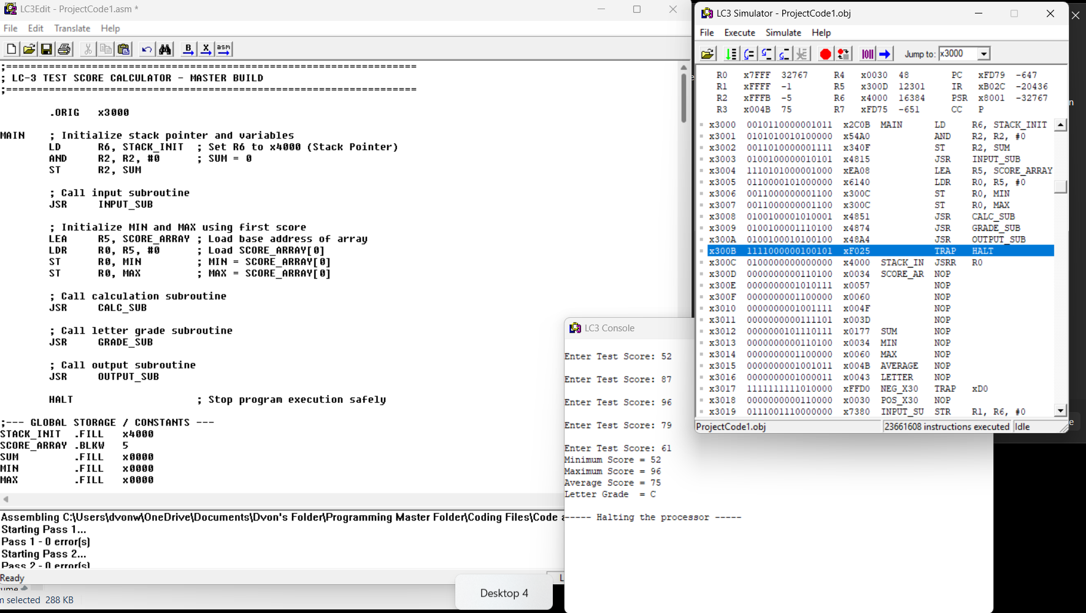
Address Location Reference:
1. x300C: Holds the runtime pointer label STACK_INIT (initialized to x4000).
2. x300D – x3011: Comprises the contiguous 5-word block for SCORE_ARRAY, storing the five raw integer test scores (52, 87, 96, 79, and 61) sequentially.
3. x3012: Stores the accumulated running SUM total of the dataset.
4. x3013: Retains the isolated MIN score metric.
5. x3014: Preserves the isolated MAX score metric.
6. x3015: Holds the computed mathematical AVERAGE integer score.
7. x3016: Contains the evaluated ASCII character byte for the final LETTER grade.

To validate the system's operational accuracy, the binary build was tested against the mandated dataset: 52, 87, 96, 79, and 61. These values were entered sequentially through the console interface to emulate a standard user experience. The program’s input routine correctly parsed the keyboard ASCII character stream, converted the multi-digit inputs into 16-bit binary integers, and successfully stored them into the allocated score array. Upon completion of the execution, the console output was captured and cross-referenced with manual calculations, yielding a perfect match:

Execution Trace and Logic Integrity .
To verify the internal stability of the `ProjectCode1.obj` build, the simulator’s execution trace was monitored in real-time during the processing of the dataset. This analysis confirmed that the pointer-based addressing (`R5`) and iterative subtraction routines functioned exactly as modeled in the design phase. By inspecting the memory stack at the `HALT` instruction, we verified that all subroutines maintained proper return-linkage (`R7`), ensuring that the program counter returned safely to the main loop without overflow or stack corruption. This technical validation proves that the program’s logic is not only correct for this specific dataset but is also structurally resilient, providing a stable foundation for potential future expansions in data-processing complexity.

Future Improvements .
While the program currently meets all functional requirements, the following areas have been identified for future refinement to improve the application's utility and resilience.

Input Validation: The current build assumes the user will only provide valid numeric data between 0 and 100. A useful next step would be the addition of an input-checking module. This would detect non-numeric characters or out-of-range values at the point of entry and allow the user to correct their input before the data is committed to memory.

Scalability: The program is currently hard-coded to handle five test scores. The logic could be updated to allow for a dynamic number of inputs. By storing the number of scores as a variable, the calculation routines could be refactored to support any dataset size, making the tool more flexible for varied testing scenarios.

Arithmetic Precision: As the number of scores increases, there is a potential risk of exceeding the capacity of a single 16-bit register during the summation process. Future versions could implement a multi-word summation routine to ensure the program remains accurate even if used for very large data sets.

Session Management: Currently, a simulator reset is required to perform a new calculation. Implementing a "Reset" or "Clear" function within the program would allow users to initiate a new round of data entry directly from the console, significantly improving the program's efficiency for repeated use.

